**Week 5 Solutions**

**Microservices**

2. Microservices with API gateway :-

**Creating Microservices for account and loan**The code and the folder structure is attached in the **123456/microservices/account**  folder

**Output :-**

**Chrome – http://localhost:8080/accounts/00987987973432**

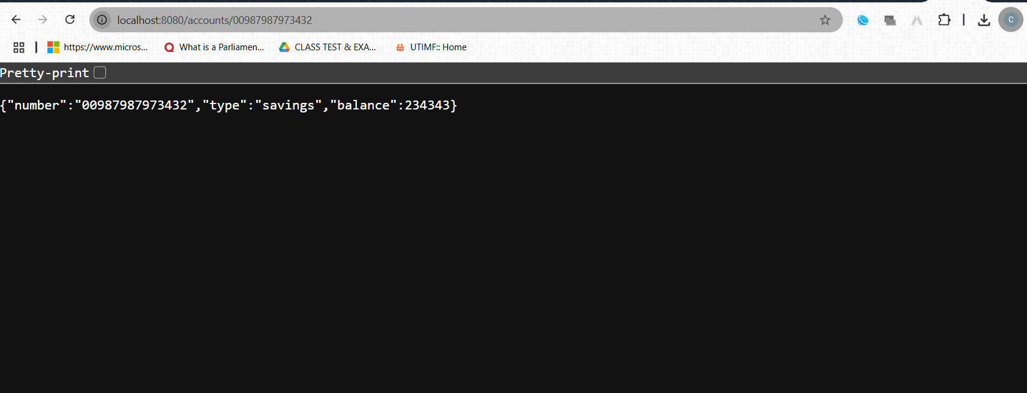

**The hands on file and folder is attached along with it**

**Loan Section :-**

The code and the folder structure is attached in the **123456/microservices/loan**  folder

**Output :-**

**Chrome –** [**http://localhost:8081/loans/H00987987972342**](http://localhost:8081/loans/H00987987972342)

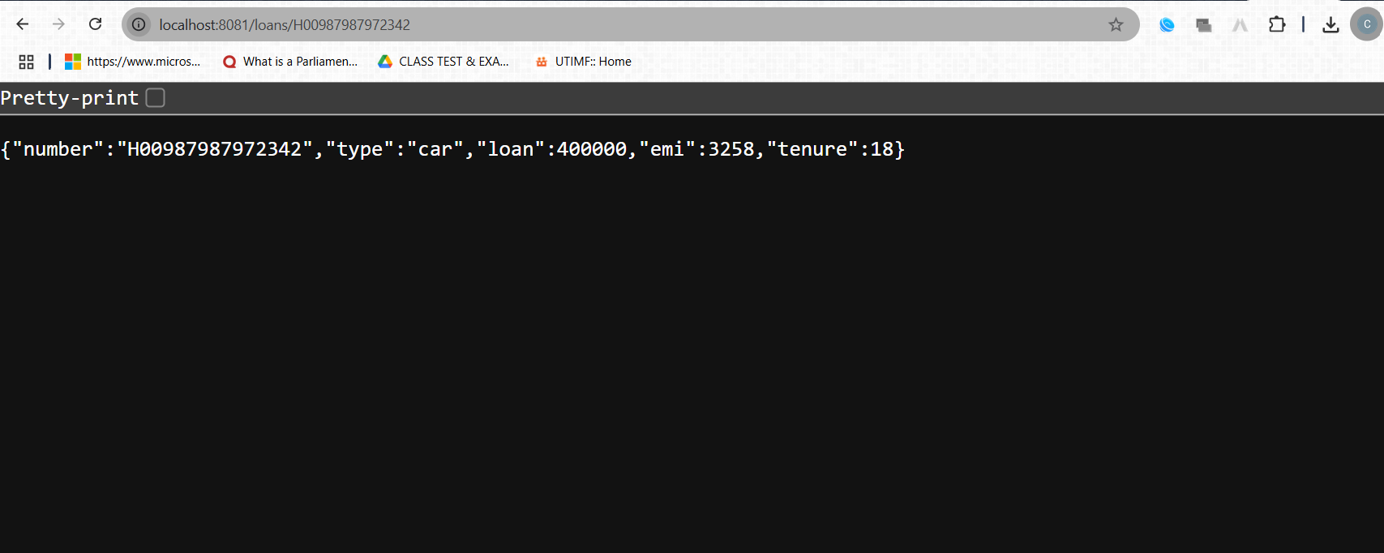

**The hands on file and folder is attached along with it**